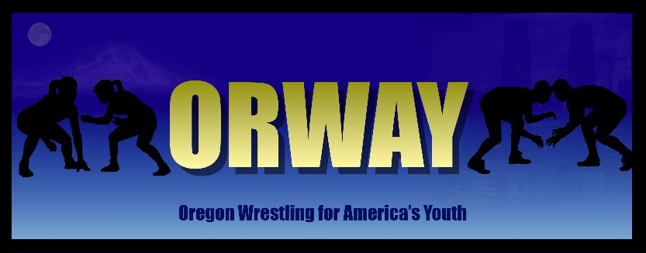
November 1, 2025
Wallowa Valley Rumble
Enterprise High School 201 SE 4th Street Enterprise, OR 97826

November 2, 2025 (Sunday)
Battle of the Blues
Walla Walla High School
800 Abbott Rd
Walla Walla, WA 99362

November 8, 2025
Cougar Challenge
Echo High School 600 Gerome Street Echo, OR 97826
OR
Grant County Wrestling Invitational
Grant Union High School
911 S Canyon Blvd
John Day, OR 97845

November 15, 2025
Round Up City Rumble
Pendleton Convention Center
1601 Westgate
Pendleton, OR 97801
Or
La Grande Slam
La Grande High School
708 K Ave #100
La Grande, OR 97850

November 22, 2025
The Battle on the Columbia
Irrigon High School
315 SE Wyoming Ave
Irrigon, OR 97844
OR
DE Bent Ear Brawl
Southridge High School
3520 Southridge Blvd
Kennewick, WA 99338

2025 Tournament Schedule

November 29, 2025
Mayhem on the Mat
McLoughlin High School
120 South Main Street
Milton-Freewater, OR 97862

December 6, 2025
Union Wrestling Tournament
Limit of 400 wrestlers
Not on Trackwrestling
Union High School
540 S Main Street
Union, OR 97883

December 7, 2025 (Sunday)
PWA Tournament
Prosser High School
1500 Paterson Road
Prosser, WA 99350

December 13, 2025
Baker Brawl
Baker High School
2500 East Street
Baker, OR 97814

December 14, 2025 (Sunday)
O-Town Throwdown
Othello High School
340 S 7th Ave
Othello, WA 99334

December 19 and 20, 2025
ORWAY Tri State Regional Tournament
Pendleton Convention Center
1601 Westgate
Pendleton, OR 97801

REMEMBER: wrestlers must wrestle in at least three league tournaments to be eligible for the regional tournament.

